Go to SE41 and create the below Z104329STAT1MATHS.

Note: The program Z104329PGM1 is already existing. The status bar is created here.

**Please use your empcode instead of 104329.**

Click on create in the screen below.

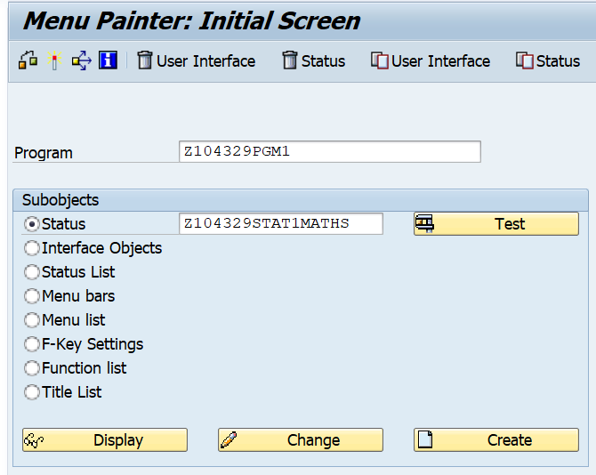

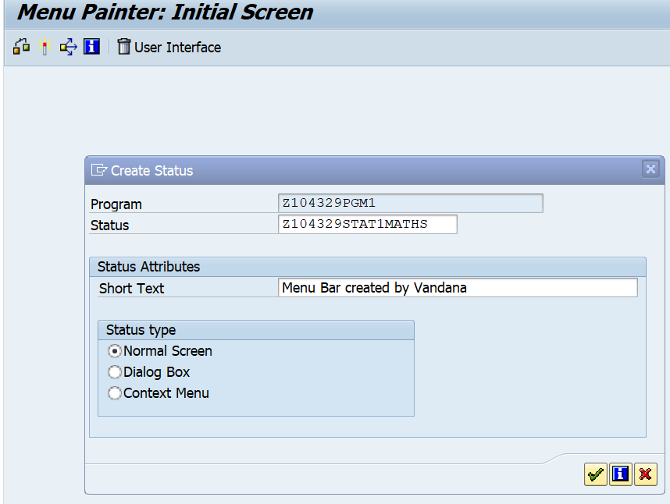

Expand the Menu Bar. i.e click on the **+** adjacent to Menu Bar.

Write Arithmetic and then double click on it to enter values for Code and Text.

Code is the FCT Code.

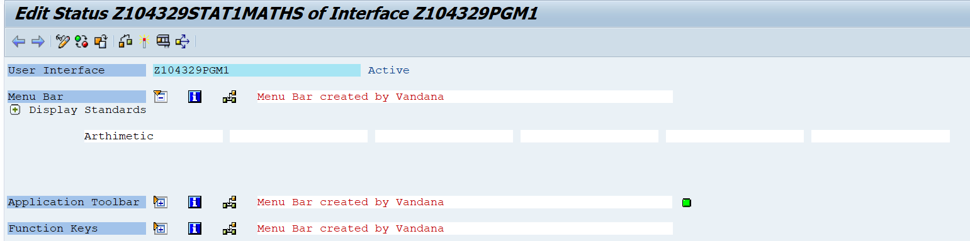

Create Menu Items and enter function code as shown below.

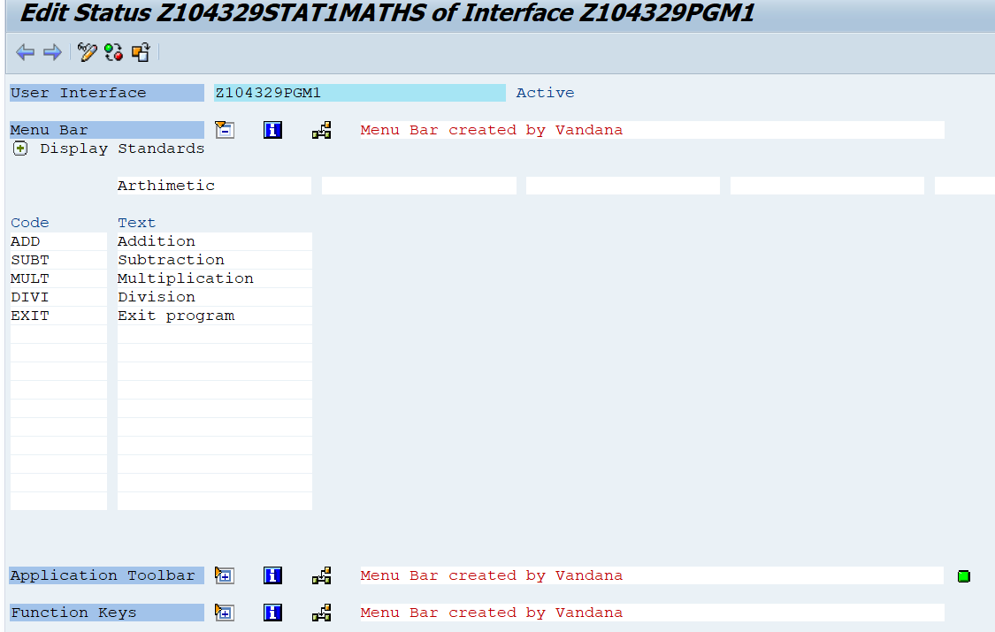

Save and Activate the Menu Bar.

Now use the Menu Bar in the program below.

REPORT z LINE-SIZE 40 NO STANDARD PAGE HEADING.  
SET PF-STATUS 'Z104329STA1TMATHS'.  
DATA: NUMBER1 TYPE I VALUE 20,  
      NUMBER2 TYPE I VALUE  5,  
      RESULT  TYPE I.  
  
START-OF-SELECTION.  
  WRITE: / NUMBER1, '?', NUMBER2.  
  
AT USER-COMMAND.  
  CASE SY-UCOMM.  
    WHEN 'ADD'.  
      RESULT = NUMBER1 + NUMBER2.  
    WHEN 'SUBT'.  
      RESULT = NUMBER1 - NUMBER2.  
    WHEN 'MULT'.  
      RESULT = NUMBER1 * NUMBER2.  
    WHEN 'DIVI'.  
      RESULT = NUMBER1 / NUMBER2.  
    WHEN 'EXIT'.  
     LEAVE PROGRAM.  
  
  ENDCASE.  
  WRITE: / 'Result:', RESULT.

